DURATION: 14:27

HEADLINE: VNR/EPK de GRISOGONO ACQUIRES THE CONSTELLATION, THE WORLD’S MOST EXPENSIVE ROUGH DIAMOND

BIENNALE DES ANTIQUAIRES, PARIS, 09 SEPTEMBER 2016

NEWS EDIT
Duration: 03:20
VARIOUS SHOTS OF EXTERIOR OF PARIS & GRAND PALAIS
VARIOUS SHOTS OF GRAND PALAIS INTERIOR AT de GRISOGONO PRESS CONFERENCE/WIDE + CLOSE-UP
(English) JOHN LEITAO, CEO OF de GRISOGONO, SAYING: “We are here today at the ‘Biennale Des Antiquaires’ at the Grand Palais in Paris to make a very special announcement for de Grisogono in what we believe is a historic moment not only for the brand but very possibly for the industry.”
VARIOUS SHOTS OF THE de GRISOGONO STAND/JEWELLERY
(English) FAWAZ GRUOSI, FOUNDER OF de GRISOGONO, SAYING: “Well today’s presentation is a historical moment for de Grisogono and I am very excited to be here today; we have some extremely amazing news to give to the press but we will leave it for later on.”
SHOT OF GRAND PALAIS INTERIOR
(English) FAWAZ GRUOSI, FOUNDER OF de GRISOGONO, SAYING: “Good morning. I have not much to say except to tell you that today is an special day for de Grisogono; we’ve been able to have - so far, after so many centuries - the best diamond as a rough today, still; the most pure, and the most clean stone ever seen in the world.
VARIOUS SHOTS OF FAWAZ GRUOSI UNVEILING THE CONSTELLATION STONE
(English) FAWAZ GRUOSI, FOUNDER OF de GRISOGONO, SAYING: “One, two, three!”
VARIOUS SHOTS OF PRESS CONFERENCE AND CLOSE-UPS OF STONE
SOUNDBITE (English): NICKOLAS POLAK, NEMESIS INTERNATIONAL DIRECTOR, SAYING: “This stone is just an incredible gift from Mother Nature; it is over 800-carats, its clarity is so perfect. And imagine it being birthed by the earth, given to all of us to see - and to be able to have something of this beauty in one place under one roof is really incredible for all of us here.”
(English) JOHN LEITAO, CEO OF de GRISOGONO, SAYING: “Never has a renowned jeweller such as de Grisogono, renowned for its creativity, taken possession of such a historic stone. This has been made possible due to our partnership with Nemesis, a long-term partnership. Nemesis is one of the largest rough diamond traders in the world and one that sources diamonds on everyday basis from the best sources.”
(English) FAWAZ GRUOSI, FOUNDER OF de GRISOGONO “I saw The Constellation and I was totally thrilled, actually I even got scared because a lot of people asked me questions - “what are you going to do with this amazing diamond?” Honestly, I’ve kept talking to that stone for a couple of weeks, trying to get feedback from her - I call her ‘her’ because she’s my princess - just to know what kind of clothes she would like to receive. And so far I don’t have an answer.”
(English) FAWAZ GRUOSI, FOUNDER OF de GRISOGONO, SAYING: “We have to wait a few months to understand exactly how much we can cut the stone and I will just say it will definitely be, as Nicky just said, the biggest diamond ever seen of that exact quality.”
VARIOUS SHOTS OF JEWELLERY IN de GRISOGONO STAND
VARIOUS SHOTS OF INTERIOR OF GRAND PALAIS

B-ROLL INTERVIEWS

INTERVIEW FAWAZ GRUOSI, FOUNDER OF de GRISOGONO
Duration: 01:06
(English) FAWAZ GRUOSI, FOUNDER OF de GRISOGONO, SAYING: “Well today is a historic moment for de Grisogono and I’m very excited to be here today, we have some extremely amazing news to give to the press but we will leave it for later on.”
(English) FAWAZ GRUOSI, FOUNDER OF de GRISOGONO, SAYING: “Well, you know, it is not science; it is a matter of talking to the stones, for example I have in my hand right now the 404, as you know, and I am constantly playing with it, looking at it, trying to talk to her until the right idea comes out so I think I still need a little bit more time to convince her to tell me the truth.”
(English) FAWAZ GRUOSI, FOUNDER OF de GRISOGONO, SAYING: “We were already at the Biennale in 2008 and since then it’s the first time we’ve come back here. I am very thrilled to be here and especially to disclose one of the most prestigious diamonds that has ever existed in the world, so later on I will be very excited to hear the comments of the press today.”

INTERVIEW JOHN LEITAO, CEO OF de GRISOGONO
Duration 00:28
(English) JOHN LEITAO, CEO OF de GRISOGONO, SAYING: “We are here today at the ‘Biennale Des Antiquaires’ at the Grand Palais in Paris to make a very special announcement for de Grisogono in what we believe is a historic moment not only for the brand but very possibly for the industry.
(English) JOHN LEITAO, CEO OF de GRISOGONO, SAYING: For us this is a very important moment: it is the moment where de Grisogono takes another very important step in its history. We’re bringing a historic stone into what is a very creative brand, something that’s truly unique.”

INTERVIEW NICKOLAS POLAK, NEMESIS INTERNATIONAL DIRECTOR
Duration: 00:26
(English) NICKOLAS POLAK, NEMESIS INTERNATIONAL DIRECTOR, SAYING: “This stone is just an incredible gift from Mother Nature; it is over 800-carats. Its clarity is so perfect. And imagine it being birthed by the Earth, given to all of us to see - and to be able to have something of this beauty in one place under one roof is really incredible for all of us here.”

B-ROLL OF PRESS CONFERENCE
Duration: 04:18
SPEECH BY FAWAZ GRUOSI, FOUNDER OF de GRISOGONO
(English) FAWAZ GRUOSI, FOUNDER OF de GRISOGONO, SAYING: “I have not much to say except to tell you that today is an special day for de Grisogono we’ve been able to have so far, after so many centuries, the best diamond as a rough today, still; the most pure, and the most clean stone ever seen in the world. Its simply 813 carats as it is today as a rough and most probably we won’t know exactly what will come out – (to Nickolas Polak) do you have any...?”

(English) NICKOLAS POLAK, NEMESIS INTERNATIONAL DIRECTOR, SAYING: Hopefully from this incredible stone we will yield top colour and hopefully the largest flawless diamond ever produced and graded eventually by the Gemmological Institute of America.

(English) SPEECH BY FAWAZ GRUOSI, FOUNDER OF de GRISOGONO, SAYING: Anyhow, we have to wait a few months to understand exactly how much we can cut the stone and I will just say it will be, definitely, as Nicky just said, the biggest diamond ever seen of that exact quality. I saw The Constellation and I was totally thrilled, actually I even got scared because as a lot of people asked be questions - "what are you going to do with this amazing diamond?” Honestly I have kept talking to the stone for a couple of weeks, trying to have feedback from her (I call her ‘her’ because she’s my princess) just to suggest to me what kind of clothes she would like to receive. And so far I don’t have any answers and actually last night I didn’t sleep because I was scared of you, because I don’t know what to tell you. Anyhow we still have another, I would say, five, six, seven months to make it happen and I am sure that from now until then I will be able to come out with something which, hopefully, no-one has seen in our industry. Because as you all now when you have a very important central stone its difficult to do something around it, you just want to just leave the queen alone without interference. And that is not in de Grisogono style. So my nightmare today is to make it simple but to make it so that when people see the object finished, it is in de Grisogono DNA. Now I am talking too much I guess. I will give back the word to –
JOHN LEITAO: Actually I think you should introduce your princess to everyone.
FAWAZ GRUOSI: Shall I do it now?
JOHN LEITAO: You should do it now.
FAWAZ GRUOSI: Ok...One, two, three! (FAWAZ and MODEL unveil the stone)

SHOT OF THE UNVEILING OF STONE BY FAWAZ AND MODEL
VARIOUS SHOTS OF FAWAZ GRUOSI NEXT TO THE STONE/BEING SHOT BY PHOTOGRAPHER/ MODEL
VARIOUS SHOTS OF THE STONE AT THE PRESS CONFERENCE
SHOT OF GRAND PALAIS INTERIOR

B-ROLL OF de GRISOGONO STAND
Duration: 00:44
VARIOUS SHOTS OF THE de GRISOGONO STAND EXTERIOR / THE de GRISOGONO LOGO
VARIOUS SHOTS OF THE de GRISOGONO STAND INTERIOR/ JEWELS/ BEAUTIES/ COCKTAILS

REVEAL FILM OF THE CONSTELLATION STONE
Duration: 02:28
FULL REVEAL FILM OF THE CONSTELLATION STONE 1min10sec
360° FILM OF CONSTELLATION STONE

GENERAL VIEWS OF GRAND PALAIS INTERIORS & EXTERIORS
VARIOUS SHOTS OF EXTERIORS OF GRAND PALAIS/BIENNALE
VARIOUS SHOTS OF INT OF GRAND PALAIS/BIENNALE

GENERAL VIEWS OF PARIS
Duration: 00:55
VARIOUS BEAUTY SHOTS OF PONT ALEXANDRE III/EIFFEL TOWER/CHAMPS ELYSEES/ARC TRIOMPHE + CONCORDE + PLACE VANDOME

[9 September 2016] – Biennale des Antiquaires, Paris
Embargo until 9 September 2016 – 10.30AM

DE GRISOGONO ACQUIRES THE CONSTELLATION,
THE WORLD’S MOST EXPENSIVE ROUGH DIAMOND

To mark the opening of the 28th Biennale des Antiquaires, de Grisogono is delighted to announce the acquisition of The Constellation, the world’s most expensive rough diamond, at a press conference held in the Grand Palais today. The purchase represents a ground-breaking moment for the company in its journey to become one of the world’s leading high jewellery and watch brands.

Measuring over six centimetres wide, The Constellation weighs 813-carats and was discovered by Canadian company, Lucara Diamond, at its Karowe mine in Botswana in November 2015. The gem was purchased for USD63 million earlier this year, following a competitive bidding process.

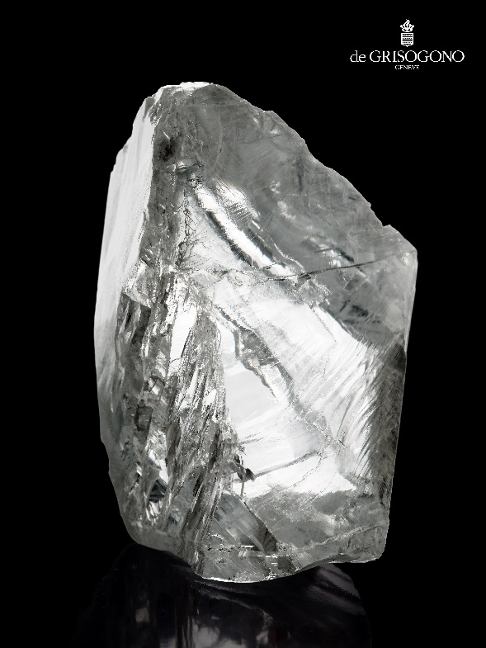

The Constellation naturally boasts the colour, clarity and carat weighting of an internationally and historically significant stone. It is expected that the cutting process, due to be completed by the middle of 2017, may unveil one of the world’s largest certified flawless diamond.

Speaking about the purchase, Founder and Executive Board member of de Grisogono, Fawaz Gruosi said:

“I am thrilled to have the chance to work with such an incredible and important diamond as The Constellation. As a jeweller I am conscious of the extraordinary responsibility I have to the stone and to the team who have worked so hard to secure it. To be able to bring my creative skills to the cutting and setting process of such a stone is both an honour and a privilege and I cannot wait to realise my vision for it.”

De Grisogono’s partnership with Nemesis International, allowing the company to market their best stones, reflects its determination to find unique gems from around the world in order to create exceptional and exclusive pieces of art for its clients. It enables de Grisogono to access the most precious rough diamonds, manage the entire cutting process and bring the very highest quality stones to its clients, combined with the distinctive de Grisogono creativity and craftsmanship.

Speaking about what the purchase means for the business, John Leitao, Chief Executive Officer of de Grisogono, said:

“By purchasing the rights to The Constellation, de Grisogono has shown its commitment to bringing the most unique stones from around the world to our clients in exceptional and exclusive pieces. We firmly believe that, despite a challenging market environment, people will continue to cherish and value those objects which are truly unique and special, such as this extraordinary piece of history.

“Our position today has been enabled by the incredible vision and creative flair of Fawaz over the last 25 years, the support of our team and our clients and, most recently, by our mutually beneficial partnership with Nemesis.”

The Constellation, represents the second major rights acquisition this year after the purchase in May of a 404-carat rough diamond, also from Nemesis International.

Speaking further about the acquisition, Nemesis International Director Nickolas Polak said:

“This deal recognises the outstanding qualities of this stone and demonstrates the enduring value of historic diamonds. It also demonstrates how, as a company, we can help mine operators sell the most remarkable stones to expert designers and creative geniuses like Fawaz Gruosi, whose international client base demands the highest quality and most exclusive gems.”

For further information please contact:

de Grisogono HQ:
Gaëlle Borgeaud +41 79 822 68 32 gaelle.borgeaud@degrisogono.com

ABOUT de GRISOGONO

In 1993, Fawaz Gruosi founded de GRISOGONO. Driven by a perpetual quest for beauty and excellence, this natural born creative and man of impeccable taste shapes daring ideas with immense talent. Creative director of the Maison, Fawaz Gruosi is passionate about exploring unusual materials and exceptional stones. 23 years after propelling the black diamond to the forefront of the international jewellery scene, Fawaz Gruosi is today regarded as one of the most innovative creative forces of his generation. His bold, iconic designs have enabled de GRISOGONO to carve out a place for itself amongst the most prestigious names in contemporary luxury.
Under Fawaz Gruosi’s guidance, de GRISOGONO has created a self-assured and instantly recognizable style that is expressed through watch and jewellery collections, and unique high jewellery pieces. Each of these creations is unique, while bearing the distinctive signatures that reflect the spirit of the Maison. Over time, its collections have become icons and sources of inspiration in their own right. An art, which at first sight appears to be astoundingly simple, yet requires incredible skill to master.

www.degrisogono.com

ABOUT NEMESIS INTERNATIONAL

NEMESIS INTERNATIONAL is a rough diamond trading company based at the Dubai Multi Commodities Center (DMCC), whose mission is to provide clients with a steady and adequately priced source of diamonds.
NEMESIS’ team has brought together years of accumulated experience in evaluating the run of mine projects; of buying and trading in the international diamond markets; and of being part of large manufacturing projects, to develop of the most in depth diamond pricing systems ever produced for the diamond industry, ensuring the best value proposal to its customers.

http://www.nemesisinternational.com

